Weapons of An Abuser:

Power and Control

Domestic Violence Help for Women
Adapted from the Domestic Abuse Intervention Project Duluth, MN

Weapons of an abuser chart
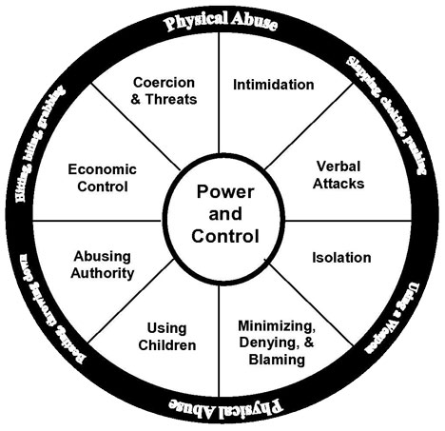
This wheel symbolizes the relationship of physical abuse to other forms of abuse. Each spoke represents a manipulative tactic used to gain power or control. The rim (physical abuse) supports the spokes (manipulative tactics) and gives the abuser his strength.
- Intimidation – Yelling, screaming, belittling, “playing with weapons”.
- Verbal attacks – Lowers victim’s self-esteem and invalidates perception.
- Isolation – Victim becomes prisoner in her own home.
- Minimizing, Denying, Blaming – “You made me hit you.”
- Using Children – Threatens to kidnap them or take custody.
- Abusing Authority – Distortion of scriptures to demand total obedience.
- Economic Control – Traps victim without means to get help.
- Coercion & Threats – Keeps victim in continual fear and submission.
- Physical Violence – Used to instill fear and regain power and control.

Healthy Relationships
This wheel represents God’s design for relationships. The eight components are held together by Mutuality, each person submitting and serving the other. The core is Equality for each image bearer of God.
In Genesis 1:26-27 (NIV), “Then God said, Let us make man in our image in our likeness, and let them rule over the fish of the sea and the birds of the air; over the livestock, over all the earth, and over all the creatures that move along the ground. So God created man in his own image, in the image of God He created him; male and female.”
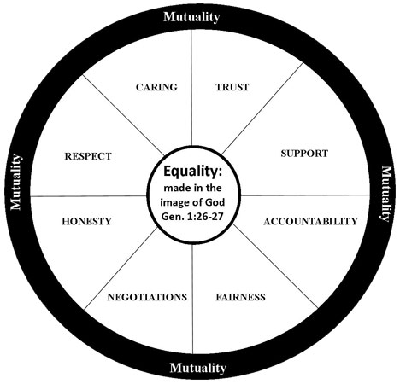
- Respect: Being emotionally present, listens without condemning and judging, affirms, values and understands each other’s opinions, ideas, feelings, beliefs, and perspectives, does not force or put pressure to do something
- Caring: Accepts me as I am, give and take on both sides, looking out for the best interest of the other person, meeting each other’s needs, gives “space” when needed concern and compassion for each other
- Trust: Confidentiality is upheld, no gossiping, follows through on promises made, keeps one’s word, feels safe
- Support: Support each other’s goals in life and encourages personal growth, encourages and affirms talents and abilities, provides emotional support when needed, encourages one another to have other friends
- Honesty: Communicates openly and truthfully, not deceiving or manipulating, forgives the other person’s offense
- Negotiations: Seeks mutually satisfying solutions to conflict, accepting change, can disagree without being judged or condemned
- Fairness: Being willing to compromise, listens to and gives thoughtful consideration to the other person’s opinions and ideas, seeing and understanding the other person’s perspective
- Accountability: Accepting responsibility for one’s actions, owning one’s problems and issues, says “I was wrong” and changes their behavior, not blaming the other person for one’s behavior

